- Purpose
  - The purpose of this document is to describe the procedure for packaging a low speed or a dual speed machine.
- Scope
  - This SOP applies to all equipment assembly team members. The process applies to the following machines:
E083013EQM0600BE1200 – Crewman 17HD Heavy Duty Floor Machine 17”
E083013EQM0607BE1200 – Crewman 17HD Heavy Duty Floor Machine 17”-Canada
E083014EQM0600BE1200 – Crewman 20HD Heavy Duty Floor Machine 20”
E083014EQM0607BE1200 – Crewman 20HD Heavy Duty Floor Machine 20”-Canada
E085812EQM0600BE1200 – Basic Dragon Dustless Floor Machine
E083009EQM0600BE1200 – Foreman 17DS Dual Speed Floor Machine 17”
E083009EQM0607BE1200 – Foreman 17DS Dual Speed Floor Machine 17”-Canada
E083010EQM0600BE1200 – Foreman 20DS Dual Speed Floor Machine 20”
E083010EQM0607BE1200 – Foreman 20DS Dual Speed Floor Machine 20”-Canada
- Responsibilities
  - The operations manager/supervisor is responsible for enforcing this SOP.
- Materials

- Definitions

- Procedure
  - Assemble the appropriate box for the machine being packaged. For a 17” machine, use 83715 and for a 20” machine use 83714.
  - Lay the box on its side and roll the machine into it. Once the machine is all the way in the box, stand it up.
  - Make sure that all of the accessories that are shipping with machine are in the box. This includes that pad driver (E81147 for a 20” machine, E81148 for a 17” machine, or E83185 for a Basic Machine) and the manual packet.

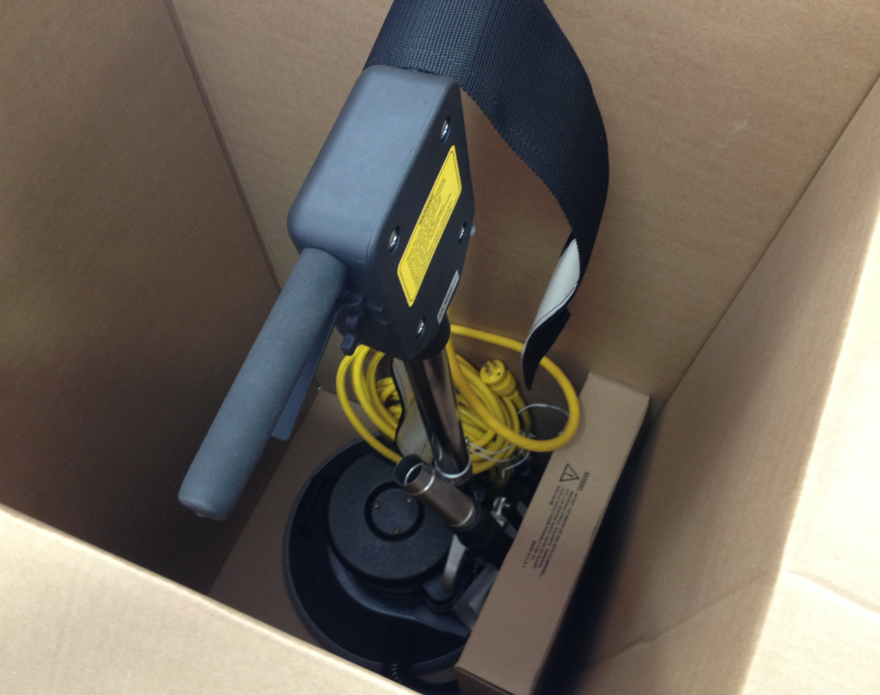
  - Place the approriate box label onto the outside of the box as shown. The inventory ID and the serial number will have barcodes. Ensure that the proper label is placed on the proper box.

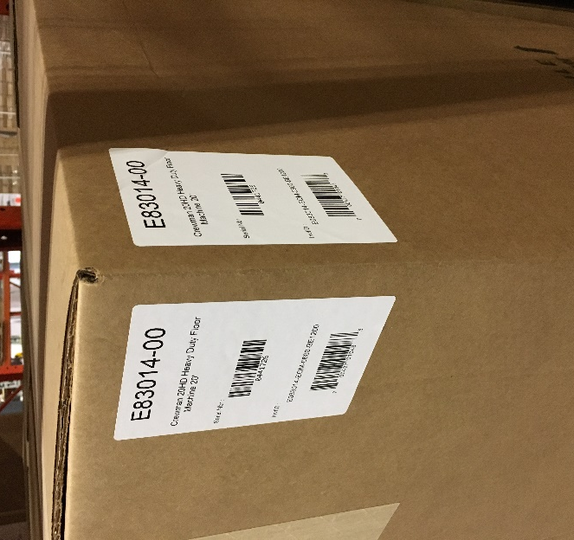

  - Tape the top of the box shut.

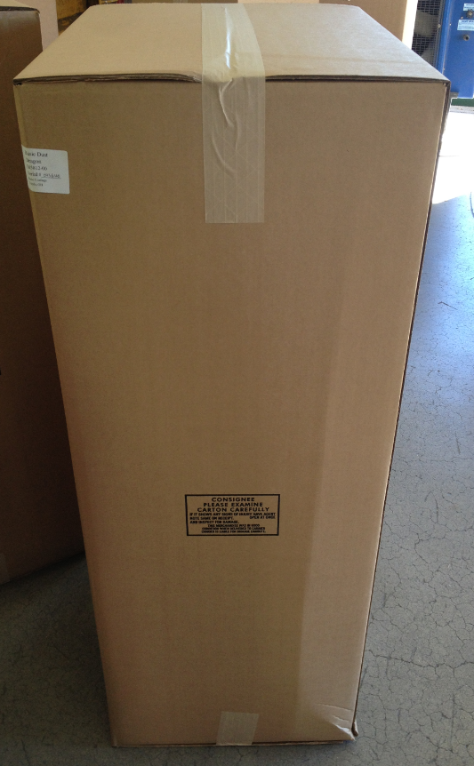

  - Put the box onto a pallet for shipment.

- References (optional section as needed)

- Training Guide

Functional Training Groups Requiring Training

- SOP Change Control

Date of Change | Reason for Change
Rev 01 - 11/19/2013 | This is the first version of the S.O.P. hence there are no revisions to this document.
Rev 02 - 1/12/2018 | Added the Responsibilities section
Rev 03 - 3/14/2025 | Removed work center notes

Approvals

Submitter/Author Approval:__________________________________ Date:______________________

Management Approval:______________________________________ Date:______________________

QAU Approval:_____________________________________________ Date:______________________

